C A G E D SYSTEM
USING THE “D” MAJOR SCALE POSITIONS

C bar chord shape for D (2nd fret) Corresponding Major Pentatonic scale for C shape in D (2nd fret) Corresponding Major scale for C shape in D (2nd fret)
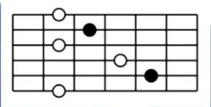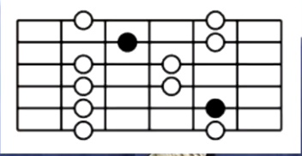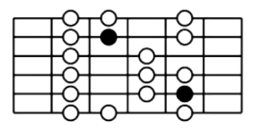
A bar chord shape for D (5th fret) Corresponding Major Pentatonic scale for A shape in D (5th fret) Corresponding Major scale for A shape in D (5th fret)
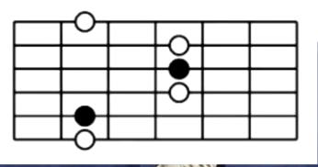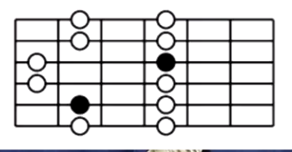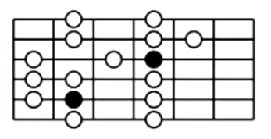
G bar chord shape for D (7th fret) Corresponding Major Pentatonic scale for G shape in D (7th fret) Corresponding Major scale for G shape in D (7th fret)
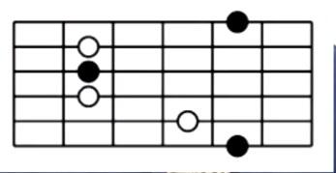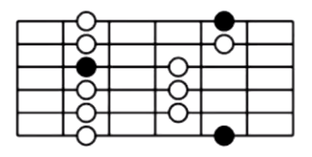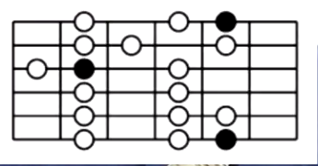
E bar chord shape for D (10th fret) Corresponding Major Pentatonic scale for E shape in D (10th fret) Corresponding Major scale for C shape in D (10th fret)
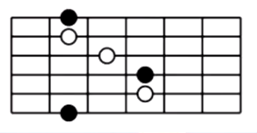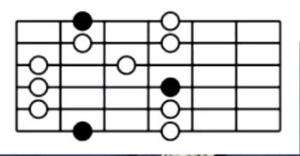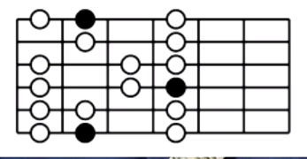
D bar chord shape for D (12th fret) Corresponding Major pentatonic scale for D shape in D (12th fret) Corresponding Major scale for D shape in D (12th fret)
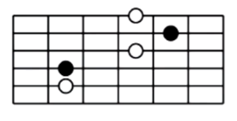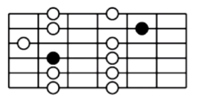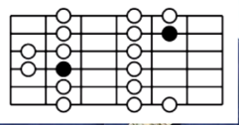

See here on YouTube for all this: CAGED Scales - Playing through all 5 positions on the guitar neck. (Steve Gilson)
https://youtu.be/Y6mF_iGxdcE NOTE: STOLEN FROM YOUTUBE-DESIGNED BY PAT FULTZ OF ACTIVBE MELODY---LOL
********************************************************************************************************************

